chapter 11

Precision Farming

In this Chapter the precision farming/ Agriculture is discussed along with its steps of implementation. It also includes how artificial Intelligence plays role to perform precision farming/ agriculture in various way along with its scope, limitation and challenges.

Introduction
The primary source of livelihood is agriculture in India, where two thirds of India’s population, services and the private sector account for the remainder. Agricultural land accounts for about 43 percent of the geographical area of India. In earlier days, India was largely dependent in terms of food imports, but over the years, the country’s production of grain and seeds was self-sufficient, and this effort led to the formation of the Green Revolution. In fact, there was strong effort to achieve food self-sufficiency. This trend has continued up to now and continuous improvements have occurred. Precision agriculture or precision farming means the right thing to do, in the right way, on the right place and at the right time. Precision agriculture is expected to suit the agro-climate activities to improve application precision. Farming land has declined a bit in the last 40 years but the number of farmers has increased. According to the 2010–11 Agriculture Census, a total of 138.35 million operating holdings were estimated (single farmers) and 159,59 million hectares were covered by operations.
Precision agriculture is a management technique that collects, processes and analyzes temporary, spatial and individual data and integrates this with other information in order to support management decisions based on an estimated variability to enhance efficiency of use of agricultural production resources, productivity, quality, profitability and sustainability. Precision Agriculture manages every input of crop production (fertilizer, specifically found calestone, herbicide, seeds, insecticide, etc. Reduce waste, boost income and maintain efficiency Place. Precision Agriculture adapts soil and crop management carefully to suit the different field conditions.

Precision Farming Concept
PFS is focused on spatial and temporal variation recognition in crop development. In farm management, variability is taken into account in order to increase productivity and reduce environmental risks. Farms are often large and cover several areas in developed countries. Therefore, spatial variability in large farms has two components: internal variability and interface variability. The precise agriculture program in a field is often called site-specific cultivation management (SSCM).
SSCM refers to an agricultural management system developed that promotes variable
practices in a site- or soil-based field

Nevertheless, SSCM is no single technology, according to Batte and VanBuren (1999), but an aggregation of technologies that allows for:
- Data collection on a suitable scale at an appropriate time;
- Data interpretation and analysis to support a range of management choices;
- Applying a management response to an appropriate level at the proper time. Segarra (2002) in a PFS study in developed countries
Emphasizes for farmers the following benefits:
- Overall increase of yield: precise crop selection, the application of exact fertilizer types and doses and of herbicides as well as appropriate irrigation meet crop requirements for optimal growth and growth. This leads to increased yields, particularly in areas or fields with historically stable crop management practices.
- Improved efficiency: Advanced machinery, tools and information, support farmers in improving labor efficiency, land and time in agriculture. In the US, 1 ha of wheat or corn will be grown in just 2 hours.
- Reduced costs of production: The application of exact amounts reduces the costs of agrochemical inputs in crop production at the appropriate time. Furthermore, the overall high return reduces the cost per output unit.
- Decision-making in agricultural management: Agricultural machinery, equipment, and devices are used in farmers to obtain reliable information that is processed and evaluated for appropriate decision makers when planting, seeding, fertilizing, applying pesticides and herbicides, irrigating, draining and post-producting.
- Reduced effect on climate: The timely application at a appropriate rate of agrochemicals avoids excessive soil and water residues and decreases contamination in the natural area.
- Accumulation of farmers’ awareness to improve management: All of PFS operations in the field yield useful information on the field and the management and the data is preserved in equipment and computers.

Steps in Precision Farming
The basic steps in precision farming are

Assessing variation
The first critical step in precision farming is the assessment of variability. Because it is obvious that what you don’t know cannot be managed. In terms of yield, the factors and processes that regulate or influence crop output vary over time. The precision agriculture challenge is to quantify the variability of these factors and processes, and to decide when and where the spatial and temporal change in crop yield is responsible for different combinations.
Spatial variability measurement methods are readily available and are commonly used in precise agriculture. The most important part of precision farming lies in spatial variability assessment. There are also methods for assessing temporal variability, but spatial and temporal variation are rarely recorded simultaneously. Space and time

statistics are important for us. We can see the variability in crop yield in space, but we are evolving during the growing season, which is nothing other than the time variance. Therefore, we need both space-time and precise agricultural statistics. When it come to these factors artificial Intelligence can play a huge role for acquiring all these factors with better accuracy and precision. Artificial Intelligence have various branches like machine learning, deep learning, computer vision and other technologies like data science and bigdata which can play a huge role in collection of data from farming lands to carry out precision farming very easily.

Managing variation
When variability has been properly analyzed, farmers have to align agricultural inputs with established conditions and suggestions on management. They are site-specific and use exact control equipment for applications. We should allow the most use of the technology. Regulation of site-specific variability. We should use the artificial Intelligence system so that we have pronounced the accuracy of the website and simple management. We will remember the sample site co-ordinates and use them for management when taking the soil and plant samples. It contributes to the efficient use of resources and avoids waste, which is what we want and in addition to this with the help of artificial Intelligence when can deploy various bots in the large field for field management and monitoring purpose.
The potential for improved soil fertility management accuracy and increased application control precision make the management of soil fertility an interesting but largely unproven alternative to standardized field management which can be improved with the help of artificial intelligence. The precise soil fertility management definition involves in-field variability and is correctly defined and accurately interpreted to influence crop growth, crop quality and the climate. Inputs may also be precisely applied. The greater the spatial dependence of a sustainable soil, the greater the potential and its potential importance for precision management.

Evaluation
The most important aspect of the study of the profitability of precision farming is that interest is often derived for the use of precision farming through the application of the data and not through use of technology Future changes to environmental quality. The potential benefits to the environment are often cited as reduced agrochemical usage, increased nutrients efficiency, increased input output controlled and increased soil production from degradation. Technologies that allow precision agriculture can be made feasible, agricultural principles and policy rules can make it practical and increase production efficiency or other types of value.
The term technology transfer may mean that precision farming occurs when individuals or companies actually obtain and use the technology that enables them. Although precision agriculture includes using technology to control spatial and temporal variability as well as agronomic concepts, the main word is management. In what is known as technology transfer, much attention has been focusing on how the farmer can interact. Such problems relating to operator managerial capacity, spatial

infrastructure delivery and connectivity between the various farms will fundamentally change as precision farming continues to evolve.

Artificial Intelligence in Precision Farming
As we have discussed about the precision farming and its importance in the field of agriculture now let’s see how artificial Intelligence can be used at different stages for carrying out precision farming in the agricultural land.
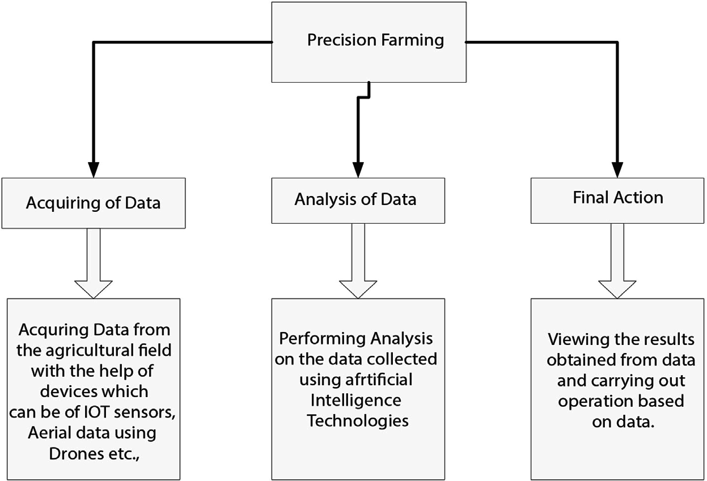

Implementation of Artificial Intelligence in Precision Farming
It can be carried out in 3 steps which are

Acquiring of Data
Acquiring or collecting of data using various technologies like IOT, Drones, Satellite Imagining etc.,
Let’s see about these technologies:
IOT in agriculture: The Internet of things is an electronically connected network of physical objects for data collection and aggregation. IoT is part of the sensors and agricultural software creation process. For liquid manure for example, farmers may spectroscopic ally calculate a substantially inconsistent sample of nitrogen, phosphorous and potassium. They can then scan the field to detect the urination of the cows and add fertilizer only to those spots which are essential. This decreases the use of fertilizers by up to 30%. Soil moisture sensors are the best times for water plants remotely.

Drone and Satellite Imaging Technology: Progress in drone and satellite technology benefits precise agriculture, as drones capture images of great quality, while satellites capture the broader picture. Light flight pilots may combine aerial imagery with satellite data to forecast future yields on the basis of current field biomass levels. Aggregate images may create contour maps to track the flow of water, evaluate the rate of seeding and create return maps for areas more or less efficient.
Robots: There have been self-management tractors for some time now as the device works like an autopilot aircraft. The tractor works best, with the farmer in an emergency. Technology is evolving into GPS-programmed driverless machinery for spreading fertilizer or plowing land. Additional innovations are solar energy machines that identify weeds and accurately kill them with an herbicide or laser dose. There are already agricultural robots, also known as Agricultural Bots, but advanced harvesting robots are being built which uses artificial Intelligence in them to detect mature fruit, adjust it to shape and size and carefully pluck it from branches.
- Analysis of Data
After collecting the data from agriculture land at a particular database we can perform various analysis for on the data using various technologies like artificial Intelligence, Machine learning, Deep learning, computer vision etc., from the analysis we can get various valuable factors which can guide us to perform several task precisely to carry out farming in the agricultural field.
- Final Action:
This step involves using various analysis and data which have collected to make various application based on them which can help to carry out precision farming in the agricultural land very easily. As now day artificial intelligence is involved more into this for making so many applications which can help any formers to perform precision farming very easily by analyzing their crops in agricultural field. The applications which can be made on basis of artificial Intelligence are
- Agriculture Bots
The majority of companies are now preparing and building robots for the main agricultural mission. This involves seed processing and work more efficiently than manpower. This is the latest example of agricultural machine learning.
- Species Breeding
Species selection is a repetitive searching method for specific genes, which decide the effectiveness of water and the use of nutrients, climate tolerance, disease resistance, nutrient content or taste. In the analysis of crop production in different climates and developing new technologies, machine-learning in particular, profound learning algorithms requires decades of field data. Based on this data, a statistical model can be developed that predicts which genes are most likely to contribute to a plant’s gain.
- Species Recognition
The conventional approach of the human person for plant classification is comparing
the color and shape of the leaves, but by using Machine Leaning’s statistical analysis

can provide quicker and more detailed results by analyzing the morphology of the leaves and provides more details about the leaf properties.
- Yield Production
Yield forecasting is one of the topics of steep-precision agriculture, as it defines yield mapping and prediction, crop demand matching and crop management. state-of - the- art techniques have gone far beyond simple prediction based through historical data, but have involved machine learning techniques to provide knowledge concerning crops, weather and economic circumstances and extensive multidimensional analysis to optimize the return for farmers and the public.
- Disease Detection or furcating of diseases
Machine Learning can be used to detect Plant infections which are typically caused by plague, insects, diseases and, unless managed on time, they reduce productivity on a large scale. Concerning the area grown in acres, the cultivators are tedious to track the crops daily. By implementing Machine Learning here provides the solution to monitor the cultivated area consistently and provides automatic detection of diseases with remote sensing images.
- Crop Quality
Data output can be adequately measured and defined to lift product price and reduce waste. Contrary to human experts, machines may use apparently irrelevant data and interfaces to discover and identify new qualities that play a role in the overall quality of the crops.
- Weed Detection
Weeds are the major threats to crop production, apart from diseases. The main issue in the war against weeds is that they are hard to distinguish and discriminate against crops. Computer vision and ML algorithms are able to enhance weed identification and discrimination at low cost without environmental issues or side effects. The technologies are going to push robots to kill weeds and reduce the need for herbicides in future.
- Soil Management
Soil is a highly diverse natural resource with complex processes and unclear mechanisms for agricultural specialists. Its own temperature can give insights into the impact on territorial returns of climate change. The algorithms of machine learning study the process of evaporation, soil humidity and temperature to understand ecosystem dynamics and the effects of agriculture.
- Water Management
The hydrological, climatological and agricultural balance of water resources in agriculture has a significance. Using more efficiently irrigated systems and a forecast of a daily dewpoint temperature, the most advanced ML applications so far are connected with an estimation of daily, weekly, or monthly stomata, which helps to classify predicted weathers and to estimation the evaporation.

- Livestock Production
Machine learning offers accurate prediction and calculation of farming parameters, in accordance with crop management, to maximize the economic efficiency of farming systems such as livestock production. In order to allow farmers to change diets and conditions, for example, weight forecasting system will be estimating future weight 150 days before the day they slaughter.

Scope and Limitation in Adoption of Precision Farming in India
Precision Farming principles are applicable to all agricultural sectors including animal breeding, fisheries and forestry. Precision Agriculture (PA, for its Spanish initials) is divided into two groups-Soft PA, Hard PA and soft PA Management assessments, rather than statistical or empirical research, based on observations and intuition. Whereas all the latest technology such as IOT, drone, GPS, GIS, VRT etc. are used as hard PA. 96 million farms in India have less than four acres (ha) of land of a total of 105,3 million farms. While only fragmented land is cultivated, India currently produces almost 200 million tons of food grain. The crop yield per hectare must be economic and without environmental damage in order to compete with world growth. In India, the total consumption of fertilizers is 84.3 Kg / ha and must be reduced in line with guidelines from the fertilizer by systematic soils testing and developing nutrient maps (Lal, 2004). Pest control, disease and weed management, along with nutrient zones, also play an important role in high crop yields. It is possible to track and manage the plague and disease at lower costs using advanced technologies. Some states, such as Punjab, Haryana use fertilizers and pesticides in large doses. The state of Punjab, for example, accounts for 1.5 percent of India’s total geographical area, but uses 1.38 million tons of NPK fertilizer (almost 10 percent of all Indians consumption) and 60 percent of weedicides used in India. Typical issues in these areas are total land degradation and inefficient use of agricultural production.
Another field in which Precision Framing will allow Indian farmers to plan irrigation more profitably by adjusting timing, quantity and water placing. Mechanizing agriculture helps farmers reduce labor costs and increase their farm precision, including selection of quality seeds, removal of weeds, pesticides and application of fertilizers, harvesting and sorting of crops according to their quality.
In developing countries in general and in India in particular, there are many constraints on the adoption of precision farming. Some of these limits are common to the ones in other areas; however, Indian conditions are specific:
- The users’ society and opinions,
- Small size field,
- No success stories,
- Heterogeneity and sector imperfections of crop systems,
- Ownership of land, facilities and institutional limits,
- Local technical skills lack
- Data accessibility, quality and expense.

Challenges
Since recent decades PA has helped to increase the yield of crops, with decreased cost and human effort, however, due to the following reasons or challenges, the adoption of these new technologies is still very limited by farmers.
- Hardware Cost: Precision Farming/Agriculture primarily relates for the measurement of multiples parameters in real time to equipment including sensors, wireless routers, drones, spectral imaging sensors, etc. These sensors have many drawbacks, including high costs for development, maintenance and operation. Many Precision Farming/Agriculture systems are inexpensive and adaptable for limited arable land,
e.g. smart irrigation systems requiring low-cost hardware and sensors. Drone-based crop safety monitoring schemes for large arable soils are not feasible because of high deployment costs.
- Change in the weather: Environmental variability is one of the greatest threats to the accuracy of sensor data. Field sensor nodes are sensitive to environmental variations, such as rain, temperature fluctuations, wind speeds, sunlight, etc. The interference caused by atmospheric disruptions in wireless channels will disrupt contact between wireless node and cloud. Also sensitive to weather changes are the satellite and air- borne drone platforms. Air pollution and other natural aerosols impact the images obtained from these platforms. The development of advanced atmospheric correction, cloud detection and sound interpolation technologies is a major challenge that requires the research community to make a strong effort.
- Excess Data Management: Data is always generated by sensors in Precision Farming/ Agriculture. Some data security measures must be put in place to ensure the integrity of data, thereby in turn increasing the system cost. The sensor readings must be precise to take appropriate action when and when necessary. The readings can be corrupted by an attacker and the machine will reduce its performance. Precision Farming/ Agriculture systems produce enormous amounts of data, requiring sufficient resources to conduct data analysis. Real-time data obtained from sensors that are deployed in a few minutes and high-altitude / low-altitude spectral imagery produces a bulk of the data that increases the storage and processing requirements. The requirements are new software platforms and scalable management facilities for big data sources. In this context, software solution generation focuses on combining data management with IoT comprehensive cloud computing platforms.
- Literacy rate: Literacy is a major factor influencing the PA adoption ratio. Farmers grow crops based on experience in developing countries with high literacy rates. They do not use state-of-the-art agriculture technologies, which lead to production loss. To understand the technology, farmers need to be educated or trust in technical support from a third party. In underdeveloped countries, the Precision Farming/ Agriculture is also not very popular due to constraints on resources and education, where the literacy rate is not high.
- Connectivity: The 5 G networks of the next generation can be 100 times faster than 4 G networks, making communication between servers and devices much faster. Furthermore, 5 G can carry far more information than other networks, making it

an ideal technology for data conveyed by remote sensors and drones, key tools tested in PA environments. In current applications, the introduction of modern 5 G communication networks is a must where safe and fast data transmission is in order to allow real-time data processing and decision-making support.
- Interoperability: The interoperability of devices due to various digital standards is one of the biggest challenges facing Precision Farming/Agriculture. This lack of interoperability not only hampers the adoption and slowing down of new IoT technologies but hinders productivity gains by smart applications in agriculture. The Precision Farming/Agriculture scenario currently provides the basis for new approaches and protocols to combine various machine communication requirements in order to explore the potential of effective machine-to - machine communication and data sharing.

Summary
Precision agriculture is a modern approach to increasing crop productivity through the use of the most up-to - date technologies, i.e. IoT, cloud computing, AI and machine Learning (ML), Deep Learning (DL), Computer Vision, Drone Technology etc., Precision Farming/Agriculture aims to provide decision support systems that are focused on a number of crop parameters, i.e. soil nutrients, soil water level, wind speed, sunlight intensity, temperature , humidity, chlorophyll content, and others. However, the development and deployment phase of these systems involves several challenges. Since precision Farming/Agriculture has as its principal objective the optimization of resources such as water, pesticides, fertilizer, etc., to produce excess yields in order to optimize resources, in order to enable artificial intelligence to quantify resources needed for healthy crops at any particular stage of growth.

